1. 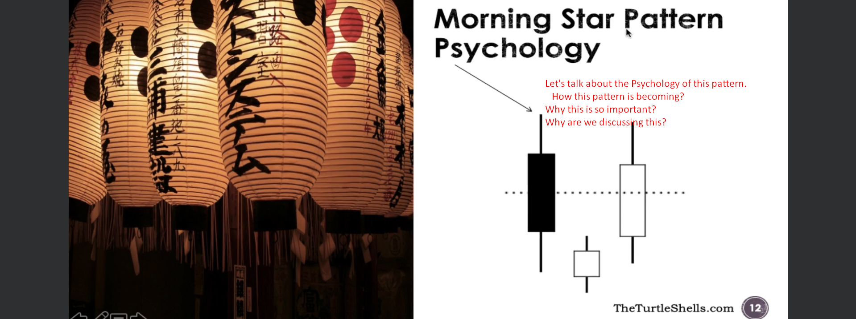
2. 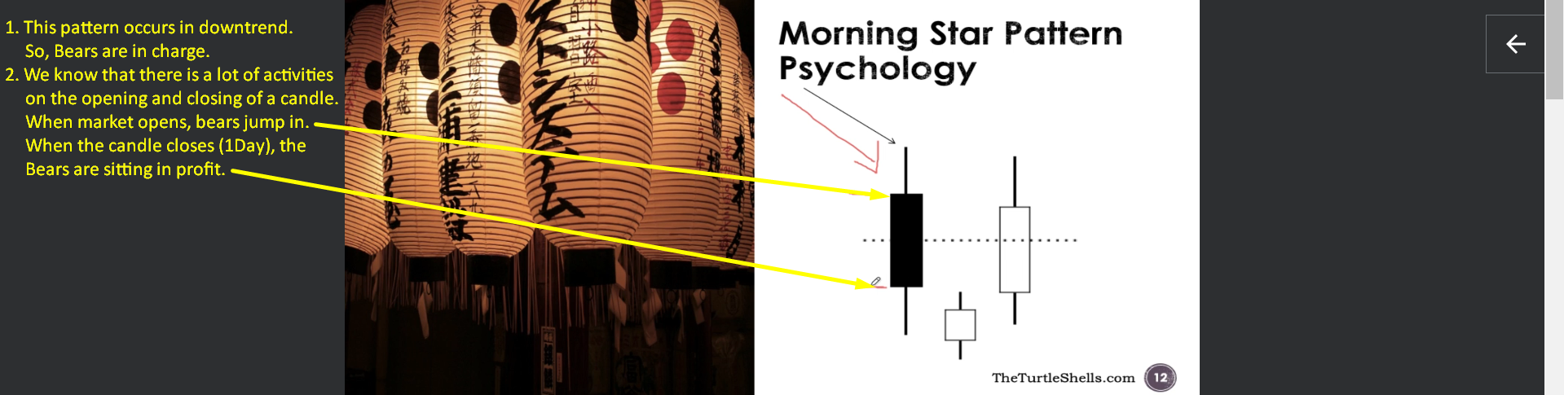
3. 2nd Spinning Candle:   
   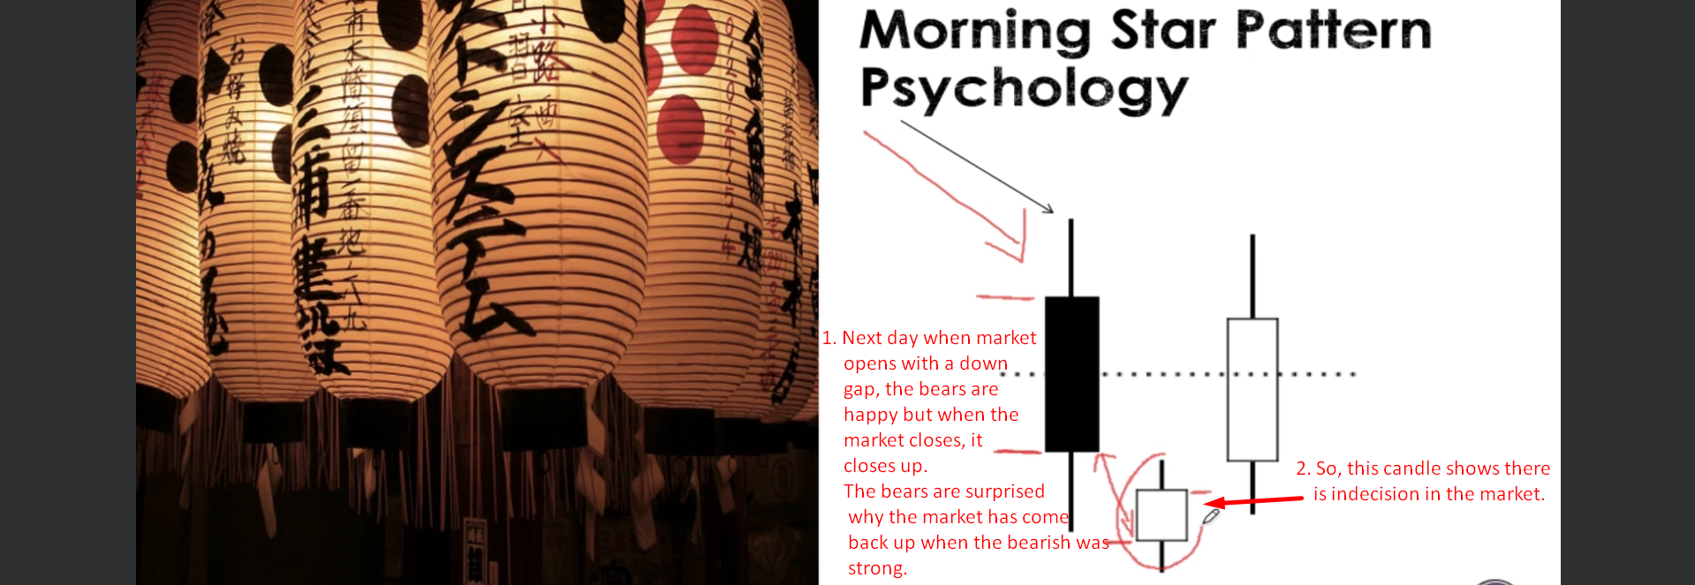There is a battle going on b/w the bears and bulls at this Spinning top or the Star.
4. The 3rd candle in the pattern will give the final confirmation that yes the bulls have won the battle because.
   1. The 3rd candle is white bullish candle which gaps up from the 2nd candle (White or Black) and closes above the mid point of the 1st black bodied candle.
5. Why we choose the lowest point of this pattern as stoploss as that is where bulls come in and they are signaling that they are not allowing the price goes below that point. So the lowest low of the pattern will become the **Support Line**.
6. 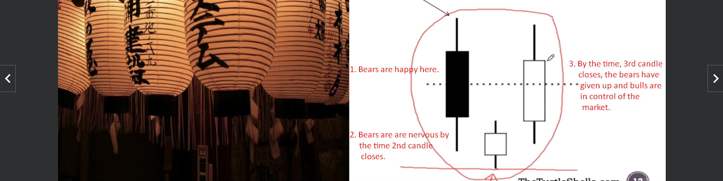
7. 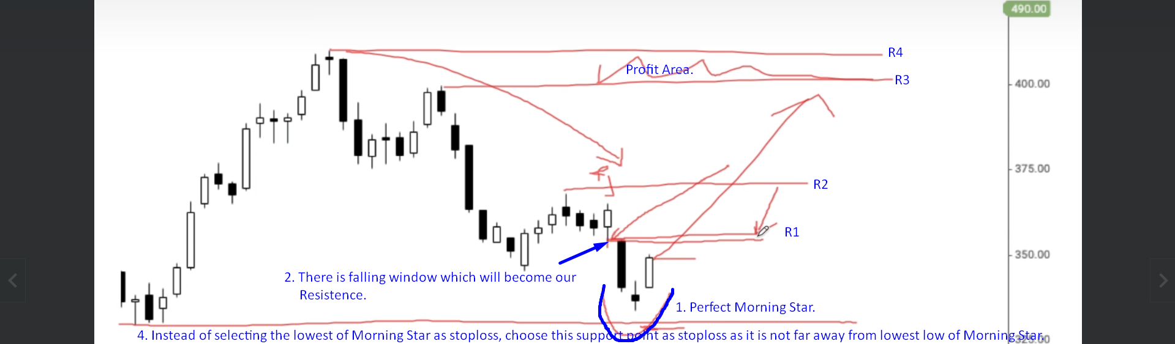
8. 